

**School of Engineering and Applied Science,**

**Ahmedabad University**

**CSE300 Software Engineering**

**Weekly Report**

**Guided By: Prof Khushru Doctor**

**TA Muskan Matwani**

**TA Anupama Nair**

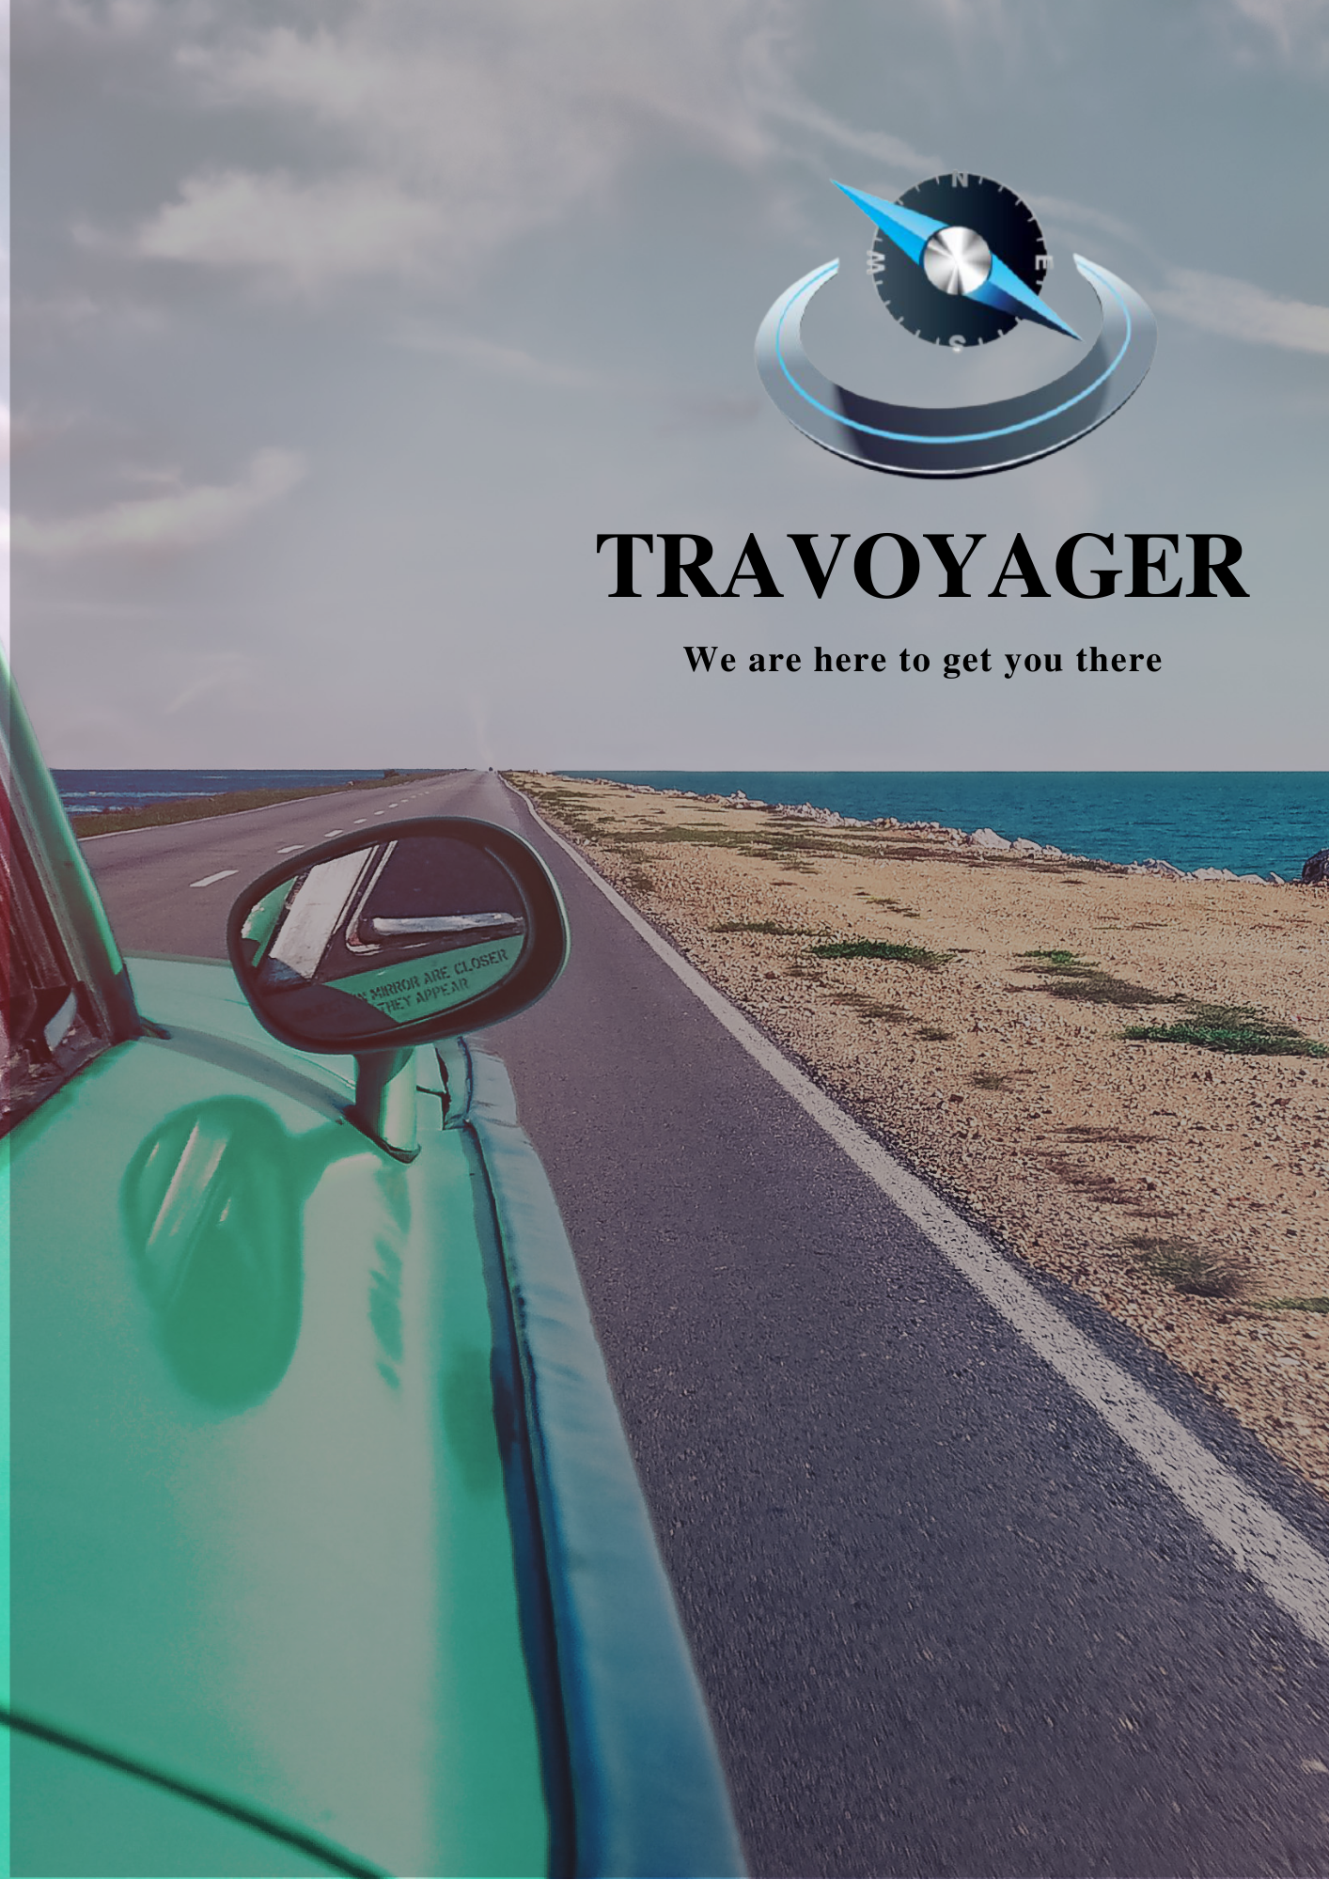

**WEEKLY MEETING REPORT - 2**

**Agenda** - Survey Conduct Preparation

**Date and Time**

**________________________________________________________________________________________________________________________________________________________________________________________________________________________________________________________________________________________________________________________________________________________________________________________________________________________________**

February 7, 2021 11:00A.M.-12:00P.M.

**Location**

**________________________________________________________________________________________________________________________________________________________________________________________________________________________________________________________________________________________________________________________________________________________________________________________________________________________________**

Google Meet

**Schedule**

**________________________________________________________________________________________________________________________________________________________________________________________________________________________________________________________________________________________________________________________________________________________________________________________________________________________________**

|  |  |
| --- | --- |
| **Time** | **Description** |
| 11:00-11:05 A.M. | Attendance |
| 11:05-11:40 A.M. | Survey questions selection |
| 11:40-11:55 A.M. | Survey form creation |
| 11:55-12:00 P.M. | Summary |
| 12:00 P.M. | Meeting Adjourned |

**Details**

**________________________________________________________________________________________________________________________________________________________________________________________________________________________________________________________________________________________________________________________________________________________________________________________________________________________________**

Based on the literature survey of existing travel websites, the questions for the form are decided in the following manner:

1. How often do you travel in a year(regularly, sometimes, once, never before)
2. Age group you belong to (0-18, 18-30, 30-55, 55 and above)
3. Gender (male, female, other)
4. How do you plan to travel(Online booking, travel agent, by own)
   1. Which website or app you use(online booking)
      1. What do you like about that website or app
5. Where do you wish to travel(beaches, trekking, hill stations, religious places, tourist popular places, multi-place visit, others)
   1. Learn about experience history and culture
   2. Rest and relaxation
   3. Trek and exploring
   4. Quality time with friends
6. With whom do you prefer to travel(solo, family, friends)
7. How many days trip do you like (range- 1 day to 30 days)
8. Budget for travel (low, moderate, expensive)

#### Level of Accommodations (please check all that apply).

* 1. Luxury hotels(five-star and other luxury establishments)
  2. First class hotels and inns such as used on guided tours(four-star and similar)
  3. Tourist class hotels and inns(three star and similar)
  4. Simple hotels(bath on hall likely)
  5. Berghauses(rugged mountain inns with private rooms)
  6. Huts(remote mountain refuges w/bunk rooms, sometimes no electricity/running water)

1. Culinary preferences.(Check all that apply) In general, finer cuisine and special diets are available in first-class and luxury establishments ony
   1. Gourmet cuisine
   2. Fine and regional continental cuisin
   3. Standard and continental cuisine
   4. Vegetarian
   5. Special dietary restrictions
2. Through which transport you prefer to travel
   1. Bus
   2. Train
   3. Own car
   4. Plane
3. If given a chance to add a new feature to any existing booking system you have seen or visited what will it be?

A survey form is created and will be circulated to all the classmates and family and friends.

**Conclusion**

**________________________________________________________________________________________________________________________________________________________________________________________________________________________________________________________________________________________________________________________________________________________________________________________________________________________________**

Form for the survey is created and circulation and response collection will continue till Feb 16 midnight.

**Next Meeting Details**

**________________________________________________________________________________________________________________________________________________________________________________________________________________________________________________________________________________________________________________________________________________________________________________________________________________________________**

February 17, 2021 4:00-5:30P.M.

**Next Agenda**

**________________________________________________________________________________________________________________________________________________________________________________________________________________________________________________________________________________________________________________________________________________________________________________________________________________________________**

Feature Discussion and Team Formation